**Personal Data**

**Curriculum Vitae**

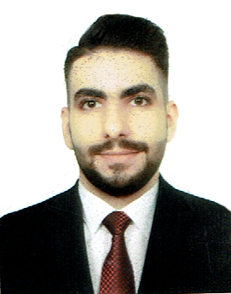

**Name : Ali Hussen Mohammed**

**Gender : male Date of Birth : 1993/1/15**

**Nationality : Iraqi**

**Address : Baghdad**

**Mobile No. : 07713380454**

**Address : Iraq / Baghdad/Al-Dora/m,838-z,2-d,4**

**Marital Status : Single**

**Email : ali.alyousifhm93@gmail.com**

**Education**

**University : Dijlah University College.**

**Faculty : Mechanical Engineering.**

**Department : Refrigeration and Air Conditioning Engineering.**

**Grade : 2015**

**Personal and Soft Skills**

* **Good Communication Skills.**
* **Self-motivated.**
* **Good Communication, Presentation, and Leadership skills.**
* **Self Planning and Time Management.**
* **Ability to face & solve problems.**
* **can work in any country or city.**
* **can work in the morning or evening.**

**Language Skills**

* **Mother language: Arabic**
* **English Very good written & spoken**

**Computer Skills**

* **Professional in dealing with Computer Software & Hardware.**
* **Professional in dealing with internet, search engines and browse through the web.**
* **Packet Tracer.**
* **Microsoft Office (Excel , Word , PowerPoint).**
* **Web.**
* **Matlab.**
* **Visual Basic.**
* **Autocade.2D,3D.**
* **Ansys.**
* **mechanicul desktop.**
* **technical drowing.**

**Work Experience**

* **As an Adminsupport.**
* **I have an experience in maintenance and installing split unit.**
* ***I worked as a salesperson at tabuk company.***
* ***I working as a salesperson at (LDP) company.***